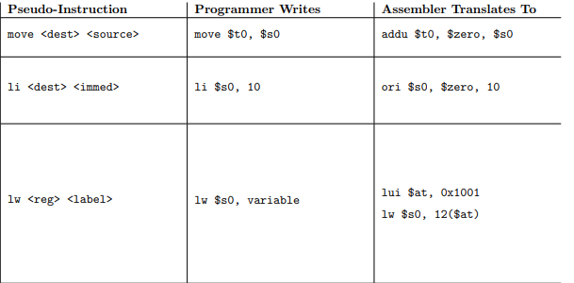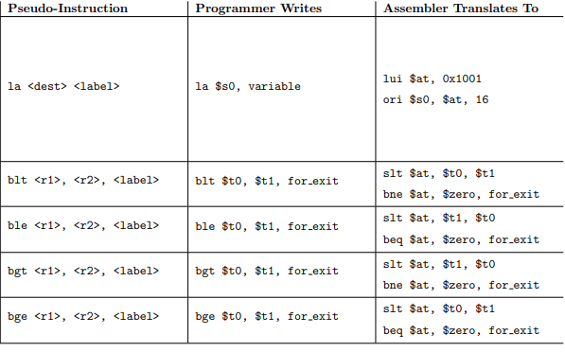

La $t0, else (0x10019323)

Lui $1, 0x1001

Ori $t0, $1, 0x9323

Li $t0, else (0x10019323)

ori $t0, $0, 10

lw $s0, else(0x21354513)

lui $1, 0x2135

lw $s0, 12($1)

move

addu $t5, $0, $s5

blt slt

bne

ble slt

beq

